**SEMINAR REPORT**

**ON**

**VIRTUAL REALITY**

**Submitted to**

**Rashtrasant Tukadoji Maharaj Nagpur University,**

**NAGPUR**

In partial fulfilment of the requirement of

**M.Sc. – (Computer Science) Semester-I Examination**

Submitted by

**PRANAY VIJAY SHAHARE**

**Under the Guidance of**

**Dr. J. K. Keche**

Assistant Professor

**Department of Computer Science**

**DEPARTMENT OF COMPUTER SCIENCE**

**Shri Shivaji Education Society Amravati’s**

**SCIENCE COLLEGE**

**Congress Nagar, Nagpur-440012.**

**2020-2021**

Department of Computer Science

Shri Shivaji Education Society Amravati’s,

Science College, Congress Nagar, Nagpur.

**CERTIFICATE**

This is to certify that **“Name of Student”** have successfully prepared the seminar report entitled “**Name of Seminar Title”** under my guidance towards the partial fulfilment of the requirement of **M.Sc. – (Computer Science) Semester-I Examination** submitted to **Rashtrasant Tukadoji Maharaj Nagpur University, Nagpur** during the academic year 2020-21.

**Place:** Nagpur Seminar Guide

**Date: 28/04/2021 Dr. J. K. Keche**

Assistant Professor

Department of Computer Science

**INDEX**

|  |  |  |
| --- | --- | --- |
| **Sr. No.** | **Name of the Topics** | **Page No.** |
| 1. | Introduction | 4 |
| 2. | Objective | 5 |
| 3. | Features | 5 |
| 4. | Working | 6 |
| 5. | Advantages and Disadvantages | 8 |
| 6. | Conclusion | 8 |
| 7. | Future Scope | 9 |
| 8. | References | 10 |

**1. Introduction:**

Virtual Reality commonly referred to as VR is a computer-generated simulation in which a person can interact within an artificial three-dimensional environment using electronic devices , such as special goggles with a screen or gloves fitted with sensors. Virtual Reality can be defined as a class of computer-controlled multisensory communication technologies. This technology was devised to enable people to deal with information more easily.

What is Virtual Reality (VR)?

Virtual Reality is a form of technology which creates computer generated worlds or immersive environment which people can explore and in many cases, interact with.

Why Virtual Reality (VR)?

VR is able to immerse you in a computer-generated world of your own making a room, a city, the interior of human body. With VR you can explore any uncharted territory of the human imagination.

Virtual reality (VR) is a simulated experience that can be similar to or completely different from the real world. Applications of virtual reality include entertainment (e.g. video games), education (e.g. medical or military training) and business (e.g. virtual meetings). Other distinct types of VR-style technology include augmented reality and mixed reality, sometimes referred to as extended reality or XR.One may distinguish between two types of VR; immersive VR and text-based networked VR (also known as "Cyberspace"). The immersive VR changes your view, when you move your head. While both VRs are appropriate for training, Cyberspace is preferred for distance learning. In some cases these two types are even complementary to each other. This page mainly focuses on the immersive VR.

Currently, standard virtual reality systems use either virtual reality headsets or multi-projected environments to generate realistic images, sounds and other sensations that simulate a user's physical presence in a virtual environment. A person using virtual reality equipment is able to look around the artificial world, move around in it, and interact with virtual features or items. The effect is commonly created by VR headsets consisting of a head-mounted display with a small screen in front of the eyes, but can also be created through specially designed rooms with multiple large screens. Virtual reality typically incorporates auditory and video feedback, but may also allow other types of sensory and force feedback through haptic technology.

**2. Objective:**

* The goal of VR is to provide human beings a virtual environment where we can interact with a computer just as we do in the real world, that is, by talking with a virtual human in a spoken language by writing a letter, or by drawing a picture.
* Ideally, user is presented with a make believe world created by the system.

**3. Features:**

* A medium of communication.
* Requires physical immersion.
* Provides synthetic sensory simulation.
* Mentally immerse the user.
* Interactivity and its captivating power contributes to the feelings of immersion, of being part of the action on the screen, that the user experiences.
* Based on current VR system, it can be concluded that three major senses are tackled by most VR system are
* Vision
* Hearing
* Touch

|  |  |
| --- | --- |
| Senses | Percentage |
| Vision | 70% |
| Hearing | 20% |
| Smell | 5% |
| Touch | 4% |
| Taste | 1% |

Mazuryk & Gervaultz (1996) shows the percentages of information that goes to human brain through human senses.

**4. Working:**

Processing of virtual reality is a combination of both hardware and software. The hardware part is used for viewing purposes, while the software can help create the environment. A simple example of this are the games, where a headgear attached with HDMI cables help transfer images from the box. This enables you to play a game of tennis with friends. In some cases, the phone becomes part of the hardware, as the smartphone get clipped in a VR headgear and project images. But a phone needs to have a 60fps framerate or higher so that the picture is not grainy and over pixelated.

Virtual reality is the presentation of a user interface in 3D. While monitors and TV screens only allow a limited 3D experience, virtual reality can be a 360-degree immersive experience, where computer-generated graphics help create things as close to reality as possible. Primary subject of virtual reality is simulating the vision. Every headset aims to perfect their approach to creating an immersive 3D environment. Each VR headset puts up a screen (or two – one for each eye) in front of eyes thus, eliminating any interaction with the real world. Two autofocus lenses are generally placed between the screen and the eyes that adjust based on individual eye movement and positioning. The visuals on the screen are rendered either by using a mobile phone or HDMI cable connected to a PC.

To create a truly immersive virtual reality there are certain prerequisites – a frame rate of minimum 60fps, an equally competent refresh rate and minimum 100-degree field of view (FOV) (though 180 degrees is ideal. The frame rate is the rate at which the GPU can process the images per second, screen refresh rate is the pace of the display to render images, and FOV is the extent to which the display can support eye and head movement.

If either of these doesn’t work as per the standards the user can experience latency i.e. too much time gap between their actions and the response from the screen. We need the response to be less than 20 milliseconds to trick the brain which is achieved by combining all the above factors in the right proportion. Another issue that needs to be catered here is to prevent tearing (cybersickness) resulting due to the inconsistency between the frame rate and refresh rate. If the GPU’s fps is more than the screen refresh rate then the image can become distorted. To counter this issue, we limit the framerate to the monitor’s refresh rate this done using a tech called Vertical Sync (VSync).

Among the major headsets available today, Vive and Rift both have 110-degree FOVs, Google Cardboard has 90, the GearVR has 96 and the new Google Daydream offers up to 120 degrees. As for frame rate, both HTC Vive and Oculus Rift come with 90hz displays, while the PlayStation VR offers a 60hz display.

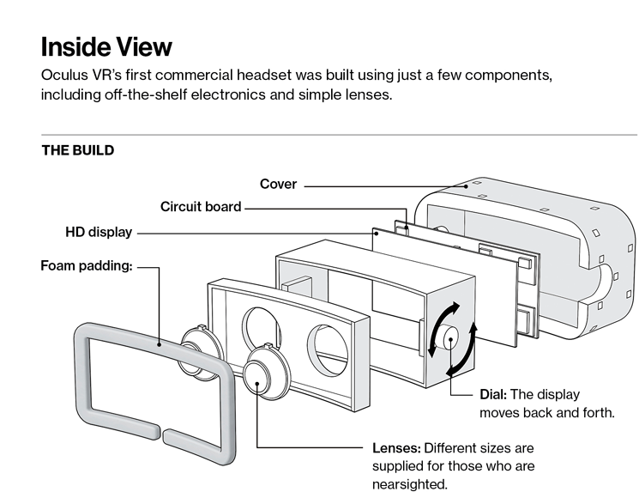

**Fig.1: Inside View**

**The Impact of Sound:**

Sound effects, when synced with the visuals, can create very engaging effects. By using a headphone and 3D sound effects the user’s belief in the virtual environment can be reassured. While crafting sound effects due care needs to be taken about the consistency between the graphics and the sound. If you start playing horror music in the background of a fairy tale movie it will just put the user off.

**Eye and Head Tracking:**

Eye and head tracking can be ensured using laser pointers, led lights or mobile sensors. In mobile, we use the accelerometer to detect three-dimensional movement, gyroscope for angular movement and magnetometer to identify the position relative to the Earth. If we need to achieve a very high accuracy then cameras and sensors can be installed in the room where you would use the headset. Although this is a much costlier setup as compared to using basic phone sensor

**5. ADVANTAGES AND DISADVANTAGES:**

**Advantages:**

1. Virtual Reality create a realistic world.
2. It enable user to explore places.
3. Through Virtual Reality user can experiment with an artificial environment.
4. Virtual Reality make the education more easy and comfortable.

**Disadvantages:**

1. The equipments used in Virtual Reality are very expensive.
2. It consists of complex technology.
3. In Virtual Reality environment we can’t move by our own like in the real world.

**7. Conclusion:**

In every generation, there is a technology that defines them.Virtual Reality is proving to be a positive impact on healthcare.The concept of Virtual Reality provides an innovative mix of entertainment, education and State-of-art.

So a virtual reality is synthetic sensory experience which may one day be indistinguishable from the real physical world.

**8. Future Scope:**

* Virtual Reality is a growing industry.
* Visualization of complicated, large data is helpful for understanding and analysis.
* PC and specialized hardware are getting better and faster because of development in VR.
* VR enables us to experience the virtual world that is impossible in real world.
* Huge demand for VRML(Virtual Reality Modelling Language) programmers in near future.
* Revolution in gaming industries.

**9. References:**

1. 3D Animation UK Studios creating Virtual Reality Pictures UK 3D Animation company has a Computer Graphics portfolio that includes UK Architectural Rendering, UK Product Visualisation,3D Virtual Tours.
2. J. Balaguer, E. Gobetts, Leaving Flatland, From the Desktop Metaphor to Virtual Reality, EUROGRAPHICS 95 Tutorial, No. 5 (1995)
3. P. Astheimer Acoustic Simulation for Visualization and Virtual Reality. EUROGRAPHICS’95 State Of The Art Reports, pp. 1-23 (1995)
4. W. Barfield, C. Hendrix: The Effect of Update Rate on the sense of Presence within Virutal Environment. Virtual Reality, Research, Development and Application, Vol, 1, No. 1, pp. 3-16 (1995)